
PATANJALI YOG PEETH (UK) TRUST
(An International Yog teaching body of PATANJALI YOG PEETH TRUST, Haridwar, India)
Charity Registration No: 1115370 (England and Wales)
Charity Registration No: SC041991 (Scotland)

Peace (Little Cumbrae) Island Trip

ENROLMENT FORM

PERSONAL DETAILS
Title: Dr / Mr / Mrs / Miss
Forename :.................................................................. Last Name :...........................................................................
D.O.B : ...................................... Sex : Male/Female Marital Status: ...............................................
Permanent Address: .............................................................................................................................................................
.......................................................................................................................... Post Code:..................................................
Telephone: (H):................................................. (W):................................................ (M):.................................................
E-mail: ..................................................................................................................................................................................
Proposed Trip From:........................... To:...........................

HEALTH DETAILS
Do you have a health problem: ◻ Yes / ◻ No. If yes, do you have doctor's approval to travel to the island: ◻ Yes / ◻ No

GENERAL INFORMATION
Are you a Yog Student ◻ Yog Teacher ◻ PYP member ◻ Other ◻

DECLARATIONS
I hereby declare the following:
- All particulars provided in the above form above are correct to the best of my knowledge
- I shall abide by all rules & regulations as detailed to me by PYPT during the course of my stay
- I shall abide by the code of conduct of Patanjali Yog Peeth (UK) Trust as prescribed for Yog Teachers / Volunteers / Students by PYPT from time to time
- I further understand that PYPT is not responsible for any loss of time should the schedule have to be changed due to unavoidable weather conditions. If extra day to stay it will be charged at £35.00 per night(need prior confirmation) .Any money is paid to the trust is non refundable.
- I understand that the accommodation provided at the island shall be basic & on a sharing basis
- I understand that I shall be responsible for my own well-being, safety and health & safe
Trust has right to change or rescheduled the trip due to weather or any other unavoidable circumstances ,NO MONEY TO BE REFUNDED

Applicant’s Signature:......................................................... Date : ..............................

Payment Details Bank Transfer: Barclays Bank
Account Name: PYPT (UK) Trust Account Sort Code: 20-78-98 Account Number:90710423

SWIFTBIC BARCGB22 IBAN GC19BAR2078 9890 7104 23

Please send a copy of the Bank Transfer Ref ; peace island trip
along with this application to: dlsohal@pranyog.co.uk

Received By: ..........................................................................................

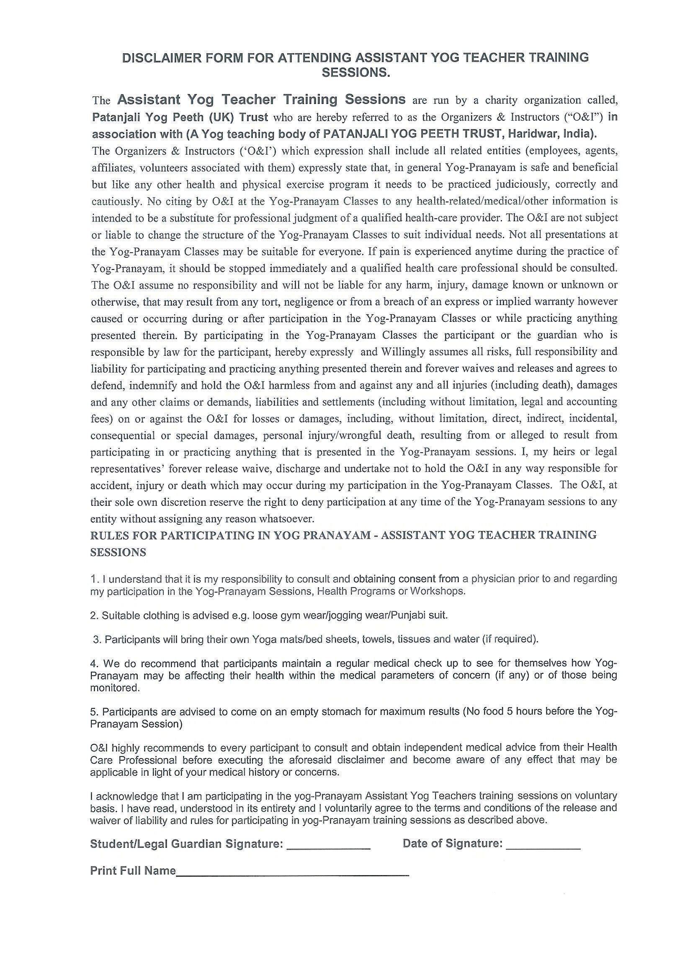
Signature: .......................................... Date: ..........................................

